

Project Report

On

**SNAKE GAME**

Submitted as partial fulfillment for the awards for the awards of

4th Semester of

BACHAELOR OF TECHNOLOGY

IN

Computer Science &Engineering

Under the guidance :- Ms. Khushbu Bharti Thakur

Submitted by : Anup Kumar Suman (22-CSE-4019)

ACKNOWLEDGEMENT

I would like to extend my deepest gratitude to my esteemed supervisor and assistant professor, Ms. Khusboo of the CSE department. Her unwavering guidance, insightful feedback, and constant support have been instrumental in the success of this project.

Her expertise and knowledge in the field have been invaluable, and her dedication to the project has been an inspiration to me. I am deeply grateful for the time, effort, and patience she has invested in me and this project. Without her invaluable support and guidance, this project would not have been possible.

I extend my heartfelt appreciation and gratitude to all of my teachers and the librarian at my college for their invaluable support and assistance throughout my project. Their expertise, guidance, and mentorship have been instrumental in helping me to understand and navigate the subject matter of my project. They have been a constant source of inspiration, providing me with the resources, feedback, and encouragement I needed to succeed. Their generosity and willingness to go above and beyond in helping me has been truly invaluable.

Table of Contents

1. 1.INTRODUCTION

2.OBJECTIVE

3.TOOLS AND TECHNOLOGIES

4.IMPLEMENTATION

5.TESTING

6.CONCLUSI0N

7.FUTURE ENHANCEMENT

INTRODUCTION

The Snake Game is a classic arcade game where the player controls a snake that moves around the screen, eating food items to grow longer. The objective is to survive as long as possible without colliding with the walls of the playing area or with the snake's own body

In this project, we delve into the realm of game development using Java, a versatile and widely-used programming language known for its portability and object-oriented design. Leveraging Java's capabilities along with Swing, AWT, and JFrame libraries, we aim to recreate the timeless allure of the Snake Game in a modern context.

Through this endeavor, we not only pay homage to a classic arcade staple but also explore the fundamentals of graphical user interface (GUI) programming and event-driven architecture. By building upon the foundation of Java's rich ecosystem of libraries and frameworks, we embark on a journey to craft a polished and engaging gaming experience.

OBJECTIVE

The objective of this project is to implement the Snake Game using Java programming language and graphical user interface components such as Swing, AWT, and JFrame.

**Implementation Proficiency**: By undertaking this project, developers aim to enhance their proficiency in Java programming and deepen their understanding of object-oriented principles.

**GUI Development Skills**: The project serves as a platform for developers to sharpen their GUI development skills using Swing and AWT libraries.

**Event-Driven Programming**: With Java's event-driven architecture, developers explore the concept of handling user input and responding to events such as key presses.

**Problem-Solving and Logic**: Developing the Snake Game involves solving a series of challenges, including snake movement, collision detection, and food generation.

TOOLS AND TECHNOLOGIES

* Java programming language
* Swing and AWT libraries for GUI

* JFrame for window management
* Classes and Methods of java

IMPLEMENTATION

**4.1. Game Initialization:**

* Create a JFrame window to display the game.
* Set up the game area with a grid layout.
* Initialize the snake at a random position with a default length.
* Place the food item at a random position within the game area.

**4.2. User Input:**

* Implement key listeners to handle user input for controlling the snake's direction (up, down, left, right).

**4.3. Snake Movement:**

* Update the snake's position based on the user's input.
* Ensure that the snake moves continuously in the chosen direction.
* Handle collisions with the game boundaries and the snake's body.

**4.4. Food Generation and Collision:**

* Check if the snake's head collides with the food item.
* If there is a collision, increase the length of the snake and generate a new food item at a random position.

**4.5. Game Over Condition:**

* Monitor the game for conditions that lead to game over, such as collisions with walls or the snake's body.
* Display a game over message when the game ends.
* Allow the user to restart the game if desired.

TESTING

* Perform thorough testing to ensure that the game functions correctly under various conditions.
* Test for different scenarios such as snake movement, collisions, and game over situations.
* Debug any issues encountered during testing.

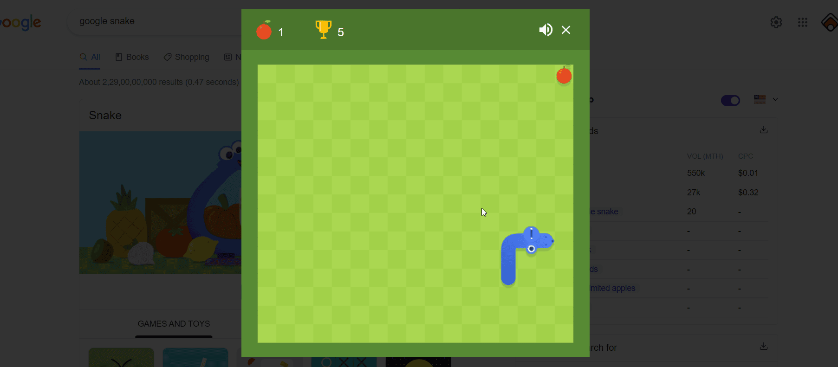

CONCLUSION

In conclusion, the Snake Game implemented using Java, Swing, AWT, and JFrame provides an entertaining and nostalgic gaming experience. By leveraging the features of these libraries, we were able to create a responsive and visually appealing game interface. This project demonstrates the application of object-oriented programming concepts and GUI programming techniques in game development with Java.

Furthermore, this project underscores the importance of collaboration and teamwork in achieving ambitious goals. Whether working independently or in a team setting, we have leveraged effective communication, coordination, and version control practices to ensure the smooth progression of the project from inception to completion.

FUTURE ENHANCEMENT

* Add sound effects and background music to enhance the gaming experience.
* Implement levels with increasing difficulty.
* Introduce power-ups and obstacles to make the gameplay more challenging.
* Incorporate multiplayer functionality for competitive gaming.
* Optimize the code for better performance and efficiency.